## **Objectives:**

The aim of this lab is to practice subqueries. We do this based on the HR database described below.

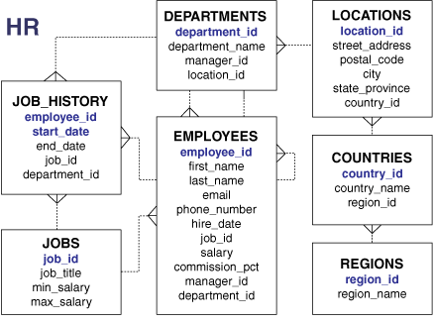

## **Lab Work:**

Sub Query syntax:

SELECT *select_list*

FROM *table*

WHERE *expr operator*

(SELECT *select_list*

FROM *table*);

1. Display all the employees who earn more than the salary of employee Abel.

SELECT last_name

FROM employees

WHERE salary >

(SELECT salary

FROM employees

WHERE last_name = 'Abel');

1. Display the employees whose job ID is the same as that of employee 141

SELECT last_name, job_id

FROM employees

WHERE job_id =

(SELECT job_id

FROM employees

WHERE employee_id = 141);

1. Display employees whose job ID is the same as that of employee 141 and whose salary is greater than that of employee 143.

SELECT last_name, job_id, salary

FROM employees

WHERE job_id =

(SELECT job_id

FROM employees

WHERE employee_id = 141)

AND salary >

(SELECT salary

FROM employees

WHERE employee_id = 143);

1. Display the employee last name, job ID, and salary of all employees whose salary is equal to the minimum salary.

SELECT last_name, job_id, salary

FROM employees

WHERE salary =

(SELECT MIN(salary)

FROM employees);

1. Display all the departments that have a minimum salary greater than that of department 50.

SELECT department_id, MIN(salary)

FROM employees

GROUP BY department_id

HAVING MIN(salary) >

(SELECT MIN(salary)

FROM employees

WHERE department_id = 50);

1. Find the job with the lowest average salary.

SELECT job_id, AVG(salary)

FROM employees

GROUP BY job_id

HAVING AVG(salary) = (SELECT MIN(AVG(salary))

FROM employees

GROUP BY job_id);

1. Find the employees whose job_id is the same as ‘Haas’

SELECT last_name, job_id

FROM employees

WHERE job_id =

(SELECT job_id

FROM employees

WHERE last_name = 'Haas');

1. Find the employees who earn the same salary as the minimum salary for each department.

SELECT last_name, salary, department_id

FROM employees

WHERE salary IN (SELECT MIN(salary)

FROM employees

GROUP BY department_id);

1. Display employees who are not IT programmers and whose salary is less than that of any IT programmer.

SELECT employee_id, last_name, job_id, salary

FROM employees

WHERE salary < ANY

(SELECT salary

FROM employees

WHERE job_id = 'IT_PROG')

AND job_id <> 'IT_PROG';

1. Display employees whose salary is less than the salary of all employees with a job

ID of IT_PROG and whose job is not IT_PROG.

SELECT employee_id, last_name, job_id, salary

FROM employees

WHERE salary < ALL

(SELECT salary

FROM employees

WHERE job_id = 'IT_PROG')

AND job_id <> 'IT_PROG';

1. Display the employees who have subordinates, use the following SQL statement:

SELECT emp.last_name

FROM employees emp

WHERE emp.employee_id IN

(SELECT mgr.manager_id

FROM employees mgr);

## **Class Exercise:**

1. The HR department needs a query that prompts the user for an employee last name. Thequery then displays the last name and hire date of any employee in the same departmentas the employee whose name they supply (excluding that employee). For example, if the user enters Zlotkey, find all employees who work with Zlotkey (excluding Zlotkey).
2. Create a report that displays the employee number, last name, and salary of allemployees who earn more than the average salary. Sort the results in order of ascendingsalary.
3. Write a query that displays the employee number and last name of all employees whowork in a department with any employee whose last name contains a *u*.
4. The HR department needs a report that displays the last name, department number, andjob ID of all employees whose department location ID is 1700.
5. Create a report for HR that displays the last name and salary of every employee who reports to King.
6. Create a report for HR that displays the department number, last name, and job ID forevery employee in the Executive department.
7. Display the employee number, last name, and salary of all employees who earn more than the average salary and who work in a department with any employee whose last name contains a *u*.